TASK 16 - EXTENDED RESPONSE 3 (SCIENCE AS A HUMAN ENDEAVOUR)

AQUEOUS SOLUTIONS AND ACIDITY (10 marks)

The map below shows the catchment for a town water supply. Describe two possible sources of contamination in this area. Three processes are required to be carried out before the people in the town use the water. Give a reason why each process is necessary and describe a method. Explain how these methods may be influenced by economic and social factors.

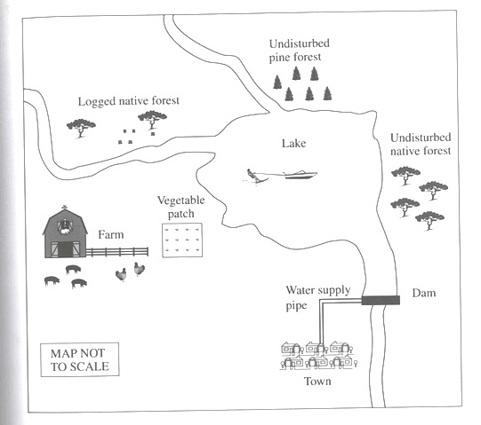

Salty Lake

Describe two possible sources of contamination: (2 marks)

1. **Animal waste leached into the water from the soil.**
2. **Petrol pollution in the lake from the boat**
3. **Fertilizers from the vegetable patch leached into water**
4. **Litter from people using the lake.**

**(Two of the above or any other reasonable answer)**

Give a reason why each process is necessary and describe each method. (6 marks)

(clearly number each process) **(ONLY 3 PROCESSES REQUIRED)**

**[2 marks for each method (1- process 1 – reason)]**

**1 Desalination**

**Reason**

**To remove the salts and minerals from water to make it suitable for drinking.**

**Method (Any suitable/logical answer)**

**1.1 Vacuum distillation  -essentially boiling it to leave impurities behind. In desalination, atmospheric pressure is reduced, thus lowering the required temperature needed. Liquids boil when the vapor pressure equals the ambient pressure and vapor pressure increases with temperature.**

**1.2 Multi-stage flash distillation - Water is evaporated and separated from sea water through multi-stage flash distillation, which is a series of flash evaporations. Each subsequent flash process utilizes energy released from the condensation of the water vapor from the previous step and so on.**

**1.3 Multiple-effect distillation (MED) works through a series of steps called “effects”. Incoming water is sprayed onto vertically or, more commonly, horizontally oriented pipes, which are then heated to generate steam. The steam is then used to heat the next batch of incoming sea water. To increase efficiency, the steam used to heat the sea water can be taken from nearby power plants. Although this method is the most thermodynamically efficient, a few limitations exist such as a max temperature and max number of effects.**

**1.4 Vapor-compression distillation**

**Vapor-compression evaporation involves using either a mechanical compressor or a jet stream to compress the vapor present above the liquid. The compressed vapor is then used to provide the heat needed for the evaporation of the rest of the sea water. Since this system only requires power, it is more efficient if kept at a small scale.**

**1.5 Reverse osmosis**

**The RO membrane processes use semipermeable membranes and applied pressure (on the membrane feed side) to preferentially induce water permeation through the membrane while rejecting salts. Desalination processes are driven by either thermal (e.g., distillation) or electrical (e.g., RO) as the primary energy types.**

**1.6 Freeze-thaw**

**Freeze-thaw desalination uses freezing to remove fresh water from frozen seawater**

**1.7 Solar evaporation**

**Solar evaporation mimics the natural water cycle, in which the sun heats the sea water enough for evaporation to occur. After evaporation, the water vapor is condensed onto a cool surface.**

**1.8 Electrodialysis reversal**

**Electrodialysis utilizes electric potential to move the salts through a membrane.**

**2. Chlorination**

**Reason**

**Used to kill certain bacteria and other microbes.**

**Method**

**When dissolved in water, chlorine converts to an equilibrium mixture of chlorine,**[**hypochlorous acid**](https://en.wikipedia.org/wiki/Hypochlorous_acid)**(HOCl), and**[**hydrochloric acid**](https://en.wikipedia.org/wiki/Hydrochloric_acid)**(HCl):**

**Cl2 + H2O ⇌ HOCl + HCl**

**In acidic solution, the major species are Cl2 and HOCl, whereas in alkaline solution, effectively only ClO− (**[**hypochlorite**](https://en.wikipedia.org/wiki/Hypochlorite)**ion) is present. Very small concentrations of ClO2−, ClO3−, ClO4− are also found.**

**3. Fluoridation**

**Reason**

**Reduces tooth decay by strengthening tooth enamel.**

**Method (Any suitable/logical answer)**

**Fluoridation is normally accomplished by adding one of three compounds to the water: sodium fluoride, fluorosilicic acid, or sodium fluorosilicate.**

* **[Sodium fluoride](https://en.wikipedia.org/wiki/Sodium_fluoride" \o "Sodium fluoride) (NaF) was the first compound used and is the**[**reference standard**](https://en.wikipedia.org/wiki/Reference_standard)**. It is a white, odorless powder or crystal; the crystalline form is preferred if manual handling is used, as it minimizes dust.**
* [**Fluorosilicic acid**](https://en.wikipedia.org/wiki/Fluorosilicic_acid)**(H2SiF6) is the most commonly used additive for water fluoridation in the United States. It is an inexpensive liquid**[**by-product**](https://en.wikipedia.org/wiki/By-product)**of phosphate fertilizer manufacture. It comes in varying strengths, typically 23–25%; because it contains so much water, shipping can be expensive. It is also known as hexafluorosilicic, hexafluosilicic, hydrofluosilicic, and silicofluoric acid.**
* [**Sodium fluorosilicate**](https://en.wikipedia.org/wiki/Sodium_fluorosilicate)**(Na2SiF6) is the sodium salt of fluorosilicic acid. It is a powder or very fine crystal that is easier to ship than fluorosilicic acid. It is also known as sodium silicofluoride.**

**Heavy Metals**

**Reason**

**Can lead to heavy metal poisoning**

**Method 1**

**Reverse Osmosis can be performant at removing low level of heavy metals, although in aerobic conditions metal oxides can clog the membranes. Also, RO is not a very cost efficient method, unless the water salt content requires further demineralisation.**

**Method 2**

**Heavy metals can be removed from groundwater with the use of a selective ion exchange resin.**

**Method 3**

**Precipitation of toxic heavy metal salts as sulfides**

**Method 4**

**Cyclic electrowinning/precipitation (CEP) system, the process involves increasing the concentration of heavy metals in water samples, until it's high enough to be effectively removed.**

**Metal-tainted water is fed into a tank, and an acid or base (such as sodium hydroxide) is added to change the water's pH value. This causes the water molecules to separate from the heavy metal precipitate, which settles to the bottom of the tank. The clean water is then siphoned off, more tainted water is introduced, and its metal content joins that already lying at the bottom. The process is repeated a number of times.**

**The settled precipitate forms into a toxic sludge, which is difficult to safely dispose of. That's where part two of CEP comes into play.**

**Once the sludge in the first tank has reached a high enough heavy metal concentration, it is pumped into a second device called a spouted particulate electrode. There, it is subjected to a process called electrowinning, in which an electrical current is used to transform the metal ions into a stable, solid, and thus easily-removed state. The water left over is then returned to the first tank, where most of the remaining metal content is settled out. That water then goes to another reservoir, where other processes are employed to further remove heavy metal ions.**

**Method 5**

**l-cysteine methyl ester - which has a similar structure to the naturally occurring amino acid cysteine – attached to the surfaces of minute glassy carbon spheres. Then the spheres are added to the water samples containing varying amounts of heavy metals, and stirred the mixtures.**

**When the glassy carbon spheres were removed the amount of toxic metal in the water was reduced significantly.**

**Method 6**

**Special absorbents are commercially available for the removal and retrieval of toxic heavy metal ions from waste water (using activated carbon, peat moss, brown coal and other cellulose materials are finding increasing application in wastewater treatment.**

Economic Factors (1 mark)

**Desalination – expensive**

**requires large amounts of energy.**

**Transport costs to/from the plant**

**When wastes are unsuitable for disposal, a suitable method or combination of methods must be selected for pre-treatment of the waste before safe disposal this can be costly.**

**(Any suitable/logical answer)**

Social factors (1 mark)

**Desalination - Disposal of concentrated waste**

**Can contain chemicals**

**Fluoridation - Education of population. View as a by product of fertilizer**

**The selection of a treatment process depends not only on the nature of the primary wastes, but also on other factors including the national regulations and the standards concerning waste.**

**(Any suitable/logical answer)**